**1. Business analyses tasks – Reports**

**1.1 Export Geo Location Reference**

*/* Formatted on 7/31/2013 4:11:48 PM (QP5 v5.139.911.3011) */*

CREATE TABLESPACE ts_sb_mbackup

DATAFILE 'SB_MBackUp_data_01.dat'

SIZE 20M

AUTOEXTEND ON NEXT 10M

SEGMENT SPACE MANAGEMENT AUTO;

CREATE USER sb_mbackup

IDENTIFIED BY "SB"

DEFAULT TABLESPACE ts_sb_mbackup;

GRANT CONNECT,RESOURCE TO sb_mbackup;

GRANT SELECT ANY TABLE TO sb_mbackup;

ALTER USER sb_mbackup QUOTA UNLIMITED ON ts_sb_mbackup;

*/* Formatted on 7/31/2013 4:11:36 PM (QP5 v5.139.911.3011) */*

CREATE TABLE denormal_export_table

AS

SELECT *--+USE_HASH(src reg part g_sys sub_grp grp grp_sys)*

country_geo_id

, cntr.country_id

, cntr.country_code_a3

, cntr.region_desc country_desc

, NVL ( g_region_id, -99 ) region_geo_id

, NVL ( reg.src_continent_id, -99 ) region_id

, NVL ( reg.region_code, 'n.d.' ) region_code

, NVL ( reg.region_desc, 'n.d.' ) region_desc

, NVL ( g_part_id, -99 ) part_geo_id

, NVL ( part.part_id, -99 ) part_id

, NVL ( part.part_code, 'n.d.' ) part_code

, NVL ( part.part_desc, 'n.d.' ) part_desc

, NVL ( g_system_id, -99 ) geo_system_geo_id

, NVL ( g_sys.src_geo_system_id, -99 ) geo_system_id

, NVL ( g_sys.geo_system_code, 'n.d.' ) geo_system_code

, NVL ( g_sys.geo_system_desc, 'n.d.' ) geo_system_desc

, NVL ( grp_item, -99 ) sub_group_geo_id

, NVL ( sub_grp.sub_group_id, -99 ) sub_group_id

, NVL ( sub_grp.sub_group_code, 'n.d.' ) sub_group_code

, NVL ( sub_grp.sub_group_desc, 'n.d.' ) sub_group_desc

, NVL ( grp_group, -99 ) group_geo_id

, NVL ( grp.GROUP_ID, -99 ) GROUP_ID

, NVL ( grp.group_code, 'n.d.' ) group_code

, NVL ( grp.group_desc, 'n.d.' ) group_desc

, NVL ( grp_sys, -99 ) grp_system_geo_id

, NVL ( grp_sys.grp_system_id, -99 ) grp_system_id

, NVL ( grp_sys.grp_system_code, 'n.d.' ) grp_system_code

, NVL ( grp_sys.grp_system_desc, 'n.d.' ) grp_system_desc

FROM ( SELECT country_geo_id

, SUM ( g_region_id ) AS g_region_id

, SUM ( g_part_id ) AS g_part_id

, SUM ( g_system_id ) AS g_system_id

, SUM ( grp_item ) AS grp_item

, SUM ( grp_group ) AS grp_group

, SUM ( grp_sys ) AS grp_sys

FROM ( SELECT CONNECT_BY_ROOT ( child_geo_id ) AS country_geo_id

, parent_geo_id

, DECODE ( link_type_id, 3, parent_geo_id ) AS g_region_id

, DECODE ( link_type_id, 2, parent_geo_id ) AS g_part_id

, DECODE ( link_type_id, 1, parent_geo_id ) AS g_system_id

, DECODE ( link_type_id, 6, parent_geo_id ) AS grp_item

, DECODE ( link_type_id, 5, parent_geo_id ) AS grp_group

, DECODE ( link_type_id, 4, parent_geo_id ) AS grp_sys

FROM u_dw_references.w_geo_object_links

CONNECT BY PRIOR parent_geo_id = child_geo_id

START WITH child_geo_id IN (SELECT DISTINCT geo_id

FROM u_dw_references.cu_countries))

GROUP BY country_geo_id) src

LEFT JOIN u_dw_references.cu_countries cntr

ON cntr.geo_id = src.country_geo_id

LEFT JOIN u_dw_references.cu_geo_regions reg

ON reg.geo_id = src.g_region_id

LEFT JOIN u_dw_references.cu_geo_parts part

ON part.geo_id = src.g_part_id

LEFT JOIN u_dw_references.cu_geo_systems g_sys

ON g_sys.geo_id = src.g_system_id

LEFT JOIN u_dw_references.cu_cntr_group_systems grp_sys

ON grp_sys.geo_id = src.grp_sys

LEFT JOIN u_dw_references.cu_cntr_groups grp

ON grp.geo_id = src.grp_group

LEFT JOIN u_dw_references.cu_cntr_sub_groups sub_grp

ON sub_grp.geo_id = src.grp_item;

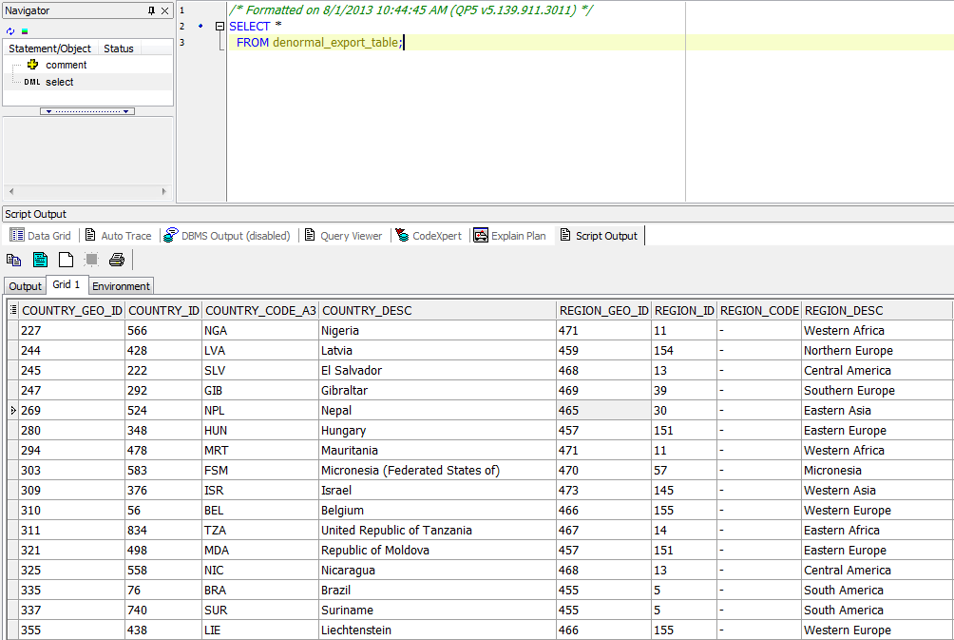

*/* Formatted on 8/1/2013 10:46:08 AM (QP5 v5.139.911.3011) */*

SELECT LPAD ( ' '

, LEVEL * 2 - 1

, ' ' )

|| child_geo_id

AS geo_id

, SYS_CONNECT_BY_PATH ( child_geo_id

, ':' )

AS PATH

, link_type_id

, CASE

WHEN LEVEL = 1 THEN 'ROOT'

WHEN CONNECT_BY_ISLEAF = 1 THEN 'LEAF'

ELSE 'BRANCH'

END

AS "LEVEL"

, CASE

WHEN CONNECT_BY_ISLEAF = 1 THEN

NULL

ELSE

( SELECT COUNT ( child_geo_id )

FROM u_dw_references.t_geo_object_links

START WITH parent_geo_id = t1.child_geo_id

CONNECT BY PRIOR child_geo_id = parent_geo_id )

END

count_of_childs

FROM (SELECT *

FROM u_dw_references.t_geo_object_links

UNION

SELECT NULL

, geo_id

, NULL

FROM u_dw_references.lc_cntr_group_systems

UNION

SELECT NULL

, geo_id

, NULL

FROM u_dw_references.lc_geo_systems) t1

START WITH parent_geo_id IS NULL

CONNECT BY PRIOR child_geo_id = parent_geo_id

ORDER SIBLINGS BY child_geo_id;

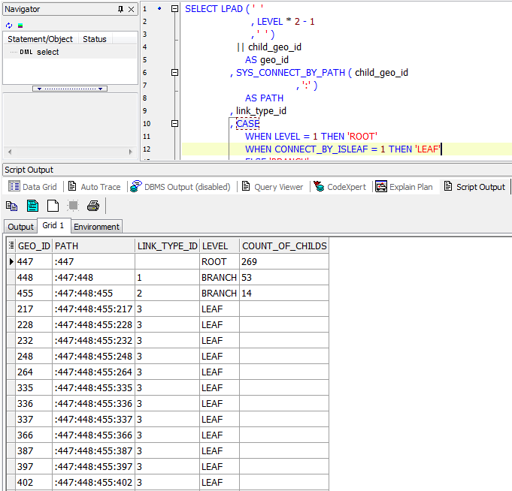

**1.2 Analyze Business** **hierarch Reference Analyses**

